# Procedures for Release Notes

Document created by Diane Hogan Jan 7, 2019

Procedures for preparing and publishing *ClientSpace* Release Notes

* Where to find content
* What to do with the content
* Where are Release Notes stored?
* How are Release Notes published?

## Creating Release Notes

Release Notes content is made available by Tony Hayes. As he completes testing, he then marks the Case as doc required and provides Release Notes content. You will receive an email notification as Tony completes release notes.

* Release Notes are created in a new Flare topic for each sprint: ReleaseNotes/R*nn*.htm
* Link to the most recent R*nn*.htm file from the Help landing page.
* Add the R*nn*.htm file to the ReleaseNotes_TOC
* Add the R*nn*.htm file to the HOME/ReleaseNotes.htm file

### To add a file for the new release note:

1. Create the file in the Release Notes folder.
2. Create the file from the ReleaseNotes_Template.htm.
3. Name the file R*nn*.htm, where *nn* represents the Sprint number.
4. Right-click the file, select **Topic Properties** tab, in **Master Page**, and select **ReleaseNotes**.

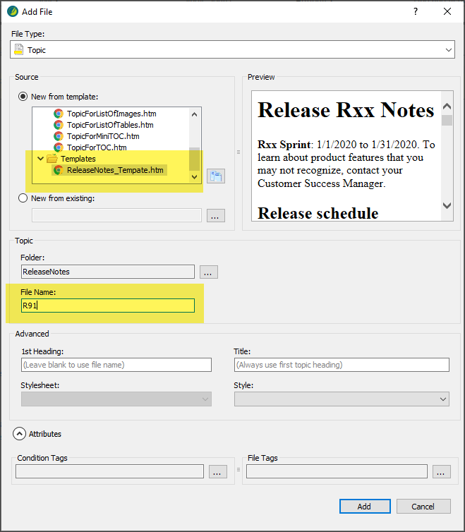

## Sprint Management Console

All processes are managed by ClientSpace in the Extranet. The objective is to open the sprint console and paste the URL of the Release Notes URL into the sprint details page. Then you progress the Workflow to the next step, and publish the Release Notes to clients via an automated email.

**To access the Sprint Management console:**

1. Go to the **Extranet**.
2. In the modules bar, click **Sprint Management**.  
   The Sprint Management list is displayed showing Cases.
3. At the bottom of the list, you will see a link titled **R*nn* Starting Velocity**. Where ***nn*** is the sprint number.
4. To access the sprint management console, click the link titled **R*nn* Starting Velocity**.  
   The Sprint Details form is displayed with the sprint number.  
   Hold this place while we obtain the next piece of information.

**To obtain the URL for the Release Notes:**

1. You activate the workflow after the new Help is pushed to the prod site.
2. Go to the most recent Rnn.htm file in the published prod Help and copy the URL.

**To complete the Workflow**:

1. On the Extranet, on the Sprint Details form, in **Legacy Release Notes**, paste the URL for the ClientSpace Release Notes.
2. Select the **Legacy Docs Complete** option.
3. Click **Apply**.  
   When you click Apply, the Workflow link is enabled.
4. In the **Action Center**, click the **Workflow** link.
5. Click **Legacy Release Notes**.  
   This action releases the document and triggers the email template for notifying clients. Additionally, after the notification is sent, the options are automatically disabled by the system. This action prevents the release notes from being sent more than once.